INTEGRATED SCIENCE

**SECTION A**

1. What name is given to the young one of a cat?

__________________________________________________________

1. In which way can heat be useful to man?

__________________________________________________________

1. State any one physical process involved in the formation of clouds.

__________________________________________________________

1. Name the body organ which store information.

__________________________________________________________

1. Why is a duck billed platypus called a mammal yet it reproduces by laying eggs?

__________________________________________________________

1. State one way of preventing metals from rusting.

__________________________________________________________

1. How is slashing around the compound help to control the spread of malaria.

__________________________________________________________

1. What is extended family?

__________________________________________________________

1. Which type of soil does do not keep water for long?

__________________________________________________________

1. Give any one example of a nocturnal animal.

__________________________________________________________

1. Name one body part where a thermometer is fixed to take the temperature.

__________________________________________________________

1. State one advantage of paddock grazing in goat keeping.

__________________________________________________________

1. How is a tongue useful in the digestion process?

__________________________________________________________

1. What happens to a plant if its planted in a vase in a dark room which has a small window to let in light.

__________________________________________________________

1. Why should food kept for future use be properly covered?

__________________________________________________________

1. In the space below draw a diagram to illustrate that heat travels through solids.
2. How can effects of floods be controlled in the environment?

__________________________________________________________

1. Suggest one way of maintaining the digestive system in good working condition.

__________________________________________________________

1. In which way can a poultry farmer control poultry diseases in the poultry house?

__________________________________________________________

1. What activity can be done by a primary six boy in order to promote environmental sanitation?

__________________________________________________________

1. What is friction?

__________________________________________________________

1. Why teeth should be brushed after a meal.

__________________________________________________________

1. How is castration important in live stock farming?

__________________________________________________________

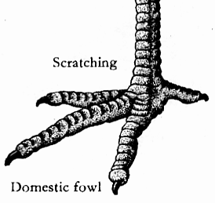

1. 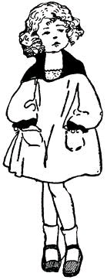[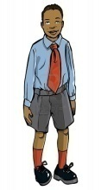](http://us.123rf.com/400wm/400/400/antonbrand/antonbrand1104/antonbrand110400233/9334802-cartoon-boy-in-school-uniform-isolated-on-white.jpg)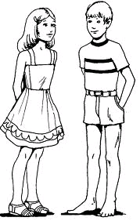Name the type of family shown below.

[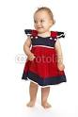](http://www.google.com/imgres?imgurl=http://t2.ftcdn.net/jpg/00/36/14/67/400_F_36146718_gZWgPKXvozqqSZO44ZIF7tBWq5s9U9k0.jpg&imgrefurl=http://www.fotolia.com/id/36146718&usg=__CPxl4-GjBkOp3nFXvRrTqb5oLqI=&h=400&w=267&sz=18&hl=en&start=11&zoom=1&tbnid=XVe8V9K0437RyM:&tbnh=124&tbnw=83&ei=6ZVAUdLAO6Sn0QW7koCwDw&prev=/search?q=a+baby+girl+standing&um=1&hl=en&gbv=2&tbm=isch&um=1&itbs=1&sa=X&ved=0CD4QrQMwCg)

[](http://www.google.com/imgres?imgurl=http://images.veer.com/Marketplace/2019480_P_One-Year-Old-Baby-Boy.jpg&imgrefurl=http://marketplace.veer.com/stock-photo/One-Year-Old-Baby-Boy-2019480&usg=__Xn9-xMP0P8IjAraje-Zm9o3f__s=&h=400&w=266&sz=42&hl=en&start=16&zoom=1&tbnid=ES0rntGGcKeakM:&tbnh=124&tbnw=82&ei=R5ZAUcrnJ-bB0QX44oDoDg&prev=/search?q=a+baby+boy+standing&um=1&hl=en&gbv=2&tbm=isch&um=1&itbs=1&sa=X&ved=0CEgQrQMwDw)[](http://www.google.com/imgres?imgurl=http://nasyidmadany.files.wordpress.com/2010/06/cga_man_black_standing.jpg&imgrefurl=http://nasyidmadany.wordpress.com/2010/06/19/&usg=__WsGgblVS6OaX_qOJnSrw8QMq7QI=&h=3075&w=2050&sz=463&hl=en&start=3&zoom=1&tbnid=t0ankezKKIvVlM:&tbnh=150&tbnw=100&ei=Y5hAUf7OFIGg0QXd5oHQCw&prev=/search?q=a+black+man+standing&um=1&hl=en&gbv=2&tbm=isch&um=1&itbs=1&sa=X&ved=0CC4QrQMwAg)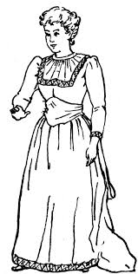[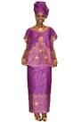](http://www.google.com/imgres?imgurl=http://www.dupsies.com/blogs/wp-content/uploads/2012/06/Brocade-Wrapper.jpg&imgrefurl=http://www.dupsies.com/blogs/tag/kitenge/&usg=__dhXe_rW17m2UeBV2UtUFjlPhibI=&h=640&w=425&sz=45&hl=en&start=57&zoom=1&tbnid=SRncEC83rEkXdM:&tbnh=137&tbnw=91&ei=opVAUey5M6Pz0gWF2oDQCw&prev=/search?q=an+old+woman+wearing+kitenge&start=40&um=1&hl=en&sa=N&gbv=2&tbm=isch&um=1&itbs=1&sa=X&ved=0CEoQrQMwEDgo)

__________________________________________________________

1. What type of change occurs when a leopard dies of an illness?

__________________________________________________________

1. How do some plants reduce the rate of transpiration?

__________________________________________________________

1. How can wind be useful I environment?

__________________________________________________________

1. Give a reason why a nurse shakes thermometer before taking the temperature reading.

__________________________________________________________

1. Identify any one product from a Marino sheep.

__________________________________________________________

1. Name any one soil pollutant.

__________________________________________________________

1. How can water promote personal hygiene??

__________________________________________________________

1. Study the diagram of a bird’s foot and answer the questions that follow.



1. What do bird’s with such kind of foot feed on?

__________________________________________________________

1. What are enzymes?

__________________________________________________________

1. Apart from having a latrine , name any one other item a healthy home should have.

__________________________________________________________

1. Give one way conduction of heat is applied in our daily life.

__________________________________________________________

1. State one advantage of biological changes in the environment.

__________________________________________________________

1. 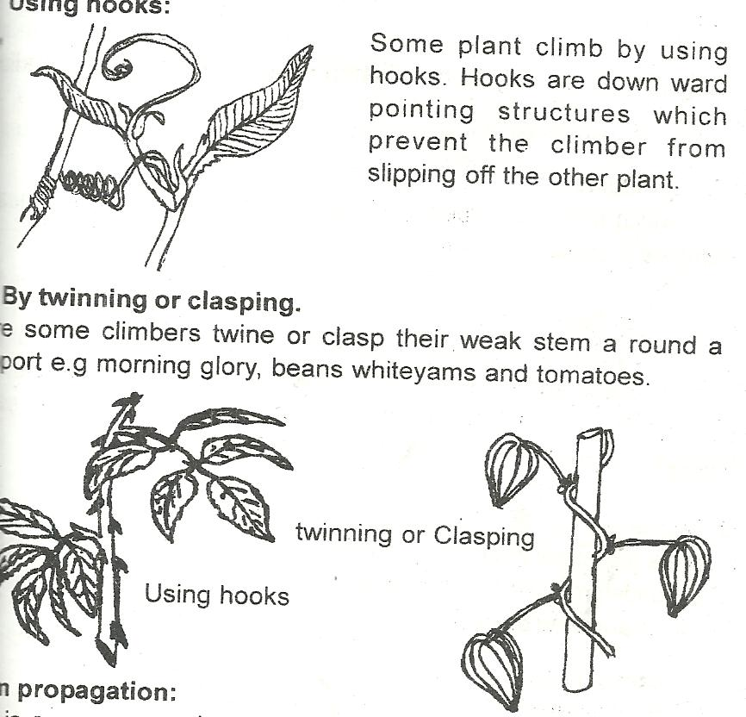How does a plant in the diagram below get support in order to get enough sunlight?

__________________________________________________________

1. How does planting trees control soil erosion in the compound?

__________________________________________________________

1. Name one material used for making composite manure.

__________________________________________________________

**SECTION B**

1. a) Define volume of an object.

__________________________________________________________

b) How can volume of an irregular object be found?

__________________________________________________________

c) List down any two examples of irregular objects.

1. ________________________________________________________
2. ________________________________________________________
3. a) State any two characteristics of living things.
4. _________________________________________________________
5. _________________________________________________________

b) Name any two major groups of living things.

1. _________________________________________________________
2. _________________________________________________________
3. Study the human body system below and answer questions that follow;

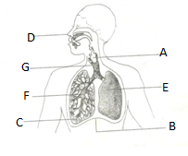

1. Name the parts labeled G and F.
2. G_____________________________________________________
3. F_____________________________________________________
4. To which system of the body does the diagram belong?

__________________________________________________________

1. State one bad health practice that may affect proper functioning of the system.

__________________________________________________________

1. a) Which component of air is used by plants to make food?

_________________________________________________________

b) Other than the above component you have named above, name any two other components of air.

__________________________________________________________

c) How does planting of many trees in environment help to reduce the component named in 44(a) above?

__________________________________________________________

1. a) Name any one product got from poultry farming.

____________________________________________________________

b) How is poultry farming important to a baking industry?

_____________________________________________________________

c) Why is it not advisable to keep turkeys together with chicken in the same room?

_____________________________________________________________

1. Write down any one disease of poultry.

__________________________________________________________

1. a) What is dehydration?

_____________________________________________________________

b) State any two causes of dehydration.

1. _________________________________________________________
2. _________________________________________________________

c) Suggest one way you can prevent one from becoming dehydrated.

__________________________________________________________

1. Match the changes that takes place in the environment in A with their descriptions in B

A B

i. Flood Abrupt falling of a mass of soil covering another area

ii. Drought -Sudden shaking of the earth which takes short time

1. Landslides - Much amount of water occupying an area of land.
2. Earth quake - Long period without water (rain)
3. Flood ___________________________________________________
4. Drought ___________________________________________________
5. Landslides ___________________________________________________
6. Earth quake ________________________________________________
7. a) What are carnivorous mammals?

________________________________________________________

b) State any two characteristics of carnivorous mammals.

1. _________________________________________________________
2. _________________________________________________________

c) Give any one example of a carnivorous mammal.

_________________________________________________________

1. a) Who is causality?

_________________________________________________________

b) Give any two reasons for giving first aid.

_________________________________________________________

c) Identify one example of first aid kit

1. a) State any two effects of heat on matter.
2. _________________________________________________________
3. _________________________________________________________

b) Convert 200c to 0F

1. a) How are the following types of weather important in environment?
2. Sunny________________________________________________________
3. Windy____________________________________________________

b) During which weather can a Campbell sunshine recorder used?

_________________________________________________________

c) How does wind help to dry wet clothes?

_________________________________________________________

1. a) Name any two types of families.
2. _________________________________________________________
3. _________________________________________________________

b) State any two roles of a father at home.

1. _________________________________________________________
2. _________________________________________________________
3. Study the diagram below and answer questions that follow;

sublimation

Gas

Q

Condensation

M N

P

1. Name the states of matter labeled Q and P.
2. Q _______________________________________________________
3. P ________________________________________________________
4. Mention the processes of change of states of matter labeled M and N
5. M _______________________________________________________
6. N _______________________________________________________
7. a) Name the two types of root.
8. _________________________________________________________
9. _________________________________________________________

b) In which one way are roots useful to;

i. Plants

_________________________________________________________

ii. Animals

_________________________________________________________

1. a) Name any three garden tools used in land preparation.
2. _________________________________________________________
3. _________________________________________________________
4. _________________________________________________________

b) Why is transplanting usually done in the evening?

_________________________________________________________